Group Development Plan

F21AS Coursework, Stage 1 Submission

***Submitted by:***  Group 6, Members listed below:

|  |  |  |
| --- | --- | --- |
| **Name** | **ID** | **Email** |
| Anwar Kamil | H00315787 | ak169@hw.ac.uk |
| Gabi Joseph Mansour | H00313528 | gj12@hw.ac.uk |
| Rohit Singh Jamwal | H00139801 | rsj30@hw.ac.uk |
| Vimal Vidyadharan | H00316629 | vv30@hw.ac.uk |
| Vishnu Subramanian | H00307008 | vs41@hw.ac.uk |

## Coursework/Project Overview

The requirements, as described in the F21AS Coursework 2019 Specification available on Vision, would be to develop an application simulating a coffee shop following the iterative development model, in two stages. Focus for this document will be Stage 1, where the key deliverables are:

1. Group Development Plan ( this document ), which describes the Software Development Plan
2. Group Report
3. The Coffee Shop Application, with the following functional requirements:
   1. Item list /menu of the coffee shop, read from a text file
   2. Order management – Display a list of orders (read from a file) and take new orders.
   3. Reporting – Generate a reports such as income for the day, count of orders by item, etc.

## Project Team and Project Plan

This coursework is taken up as a project and is named “FoodCart”, and the project team is “Group 6”. All deliverables for this coursework are available on our GitHub repository: <https://github.com/foodcart/coursework1>.

Stage 1 is planned to start from Week 2, and end by Week 7 (21/02/2019). Project team responsibilities are defined and distributed as shown below:

|  |  |  |  |
| --- | --- | --- | --- |
| **Roles/Responsibilities** | **Team members** | **Start** | **End** |
| Planning & Requirements | All members | 13/01/2019 | 21/01/2019 |
| Analysis and Design | All members | 22/01/2019 | 31/01/2019 |
| Develop - ItemList | Anwar Kamil | 02/01/2019 | 06/02/2019 |
| Develop - Orders | Gabi Mansour | 02/01/2019 | 07/02/2019 |
| Develop - GUI | Vimal Vidyadharan | 02/01/2019 | 12/02/2019 |
| Quality Assurance | Vishnu Subramanian, Rohit S. Jamwal | 13/02/2019 | 19/02/2019 |
| Documentation | Vishnu Subramanian, Rohit S. Jamwal | 20/02/2019 | 21/02/2019 |

Team meetings are planned every Sunday at the campus. In these meetings, design decisions, integration, and testing related issues will be dealt. The team will be continuously collaborating online as well.

The Gantt chart for the project plan is as show below:

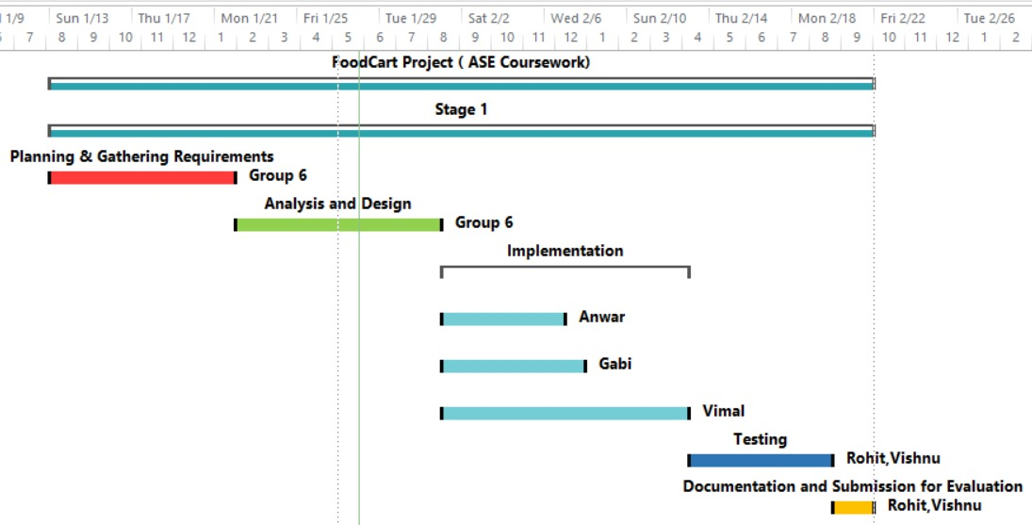

## Architecture

### Data Structures

From the analysis of the requirements, it has been decided to have 2 core data structures as given in the table below:

|  |  |  |
| --- | --- | --- |
| **Component** | **Class** | **Data Structure** |
| Items | ItemList | HashMap |
| Orders | OrderList | TreeMap |

**Items/ItemList**: Items is the list of items on the menu of the Coffee Shop. When a customer orders an item, the program will retrieve item details such as its price or description from the ItemList.   
The Itemlist is then a set/collection of Keys (Unique ID) and Values (Category, Description, and Cost) which needs to be looked up with ease. Creating the ItemList as a HashMap will ensure the collection of Key-Value pairs is easily stored and retrieved.

**Orders/OrderList:** An order represents the sale of an item from the itemList to a customer, thus the Order is a uniquely identified set of values (Customer, Item, Cost, Timestamp). The Orders collection will be thus a collection of Key-Value pairs. The orders need to be sorted based on an incremental unique ID, so that it will be displayed sorted in the report. Keeping these in mind we have decided to keep the OrderList as a TreeMap.

### Class Diagram



## Quality Assurance

We aim to keep the code bug free. Thorough testing of the developed artifacts will be done using JUnit. Any issues found in testing will be raised on the GitHub project and to be coordinated by the testing team members for quick and effective resolutions.